GAME AND WEBSITE PROPOSAL

Proposed by: Aleksandrs Lukjanovs Student Number: M00674847

Dear, Mr Adam Philpot

This is my proposition to you for creating a game called “Nerve Boost” which is going to be located at a website which I am also designing. This proposition is backed by my current sketches of the website and a few designs of player-controlled frames.

# **Website**

**Description**

Website if fairly minimalistic with animated buttons and cool moving pics that I will add. Key features are:

* Animated Buttons
* Animated Images
* Epic Music
* Clean and Minimalistic Design
* Colours will probably mimic the logo.
* Possibly a cool background.
* Stores user log in data.
* Displays Rankings.
* Hosts the Game.

**Example Wireframes:**

**Log in page** is the first thing you would see when you go to the web. It’s the log in or register page. It allows you to access all pages besides the Logged in, Game, Leaderboard. From here you could go and view game info or controls. You could log in or register. 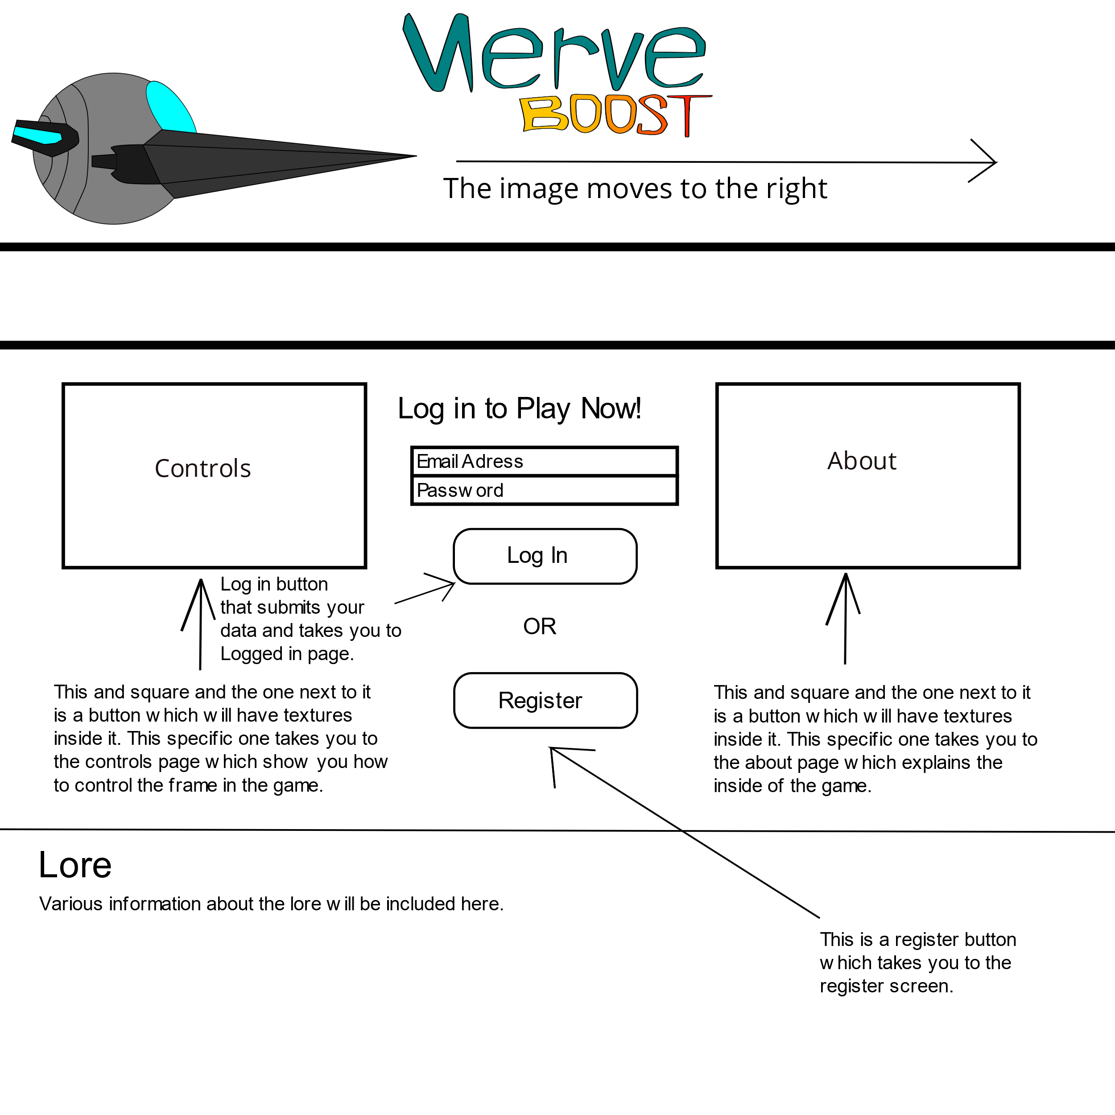

**Register page** is what you would see if you clicked register, it would give you boxes to input your data and submit it following the log in screen.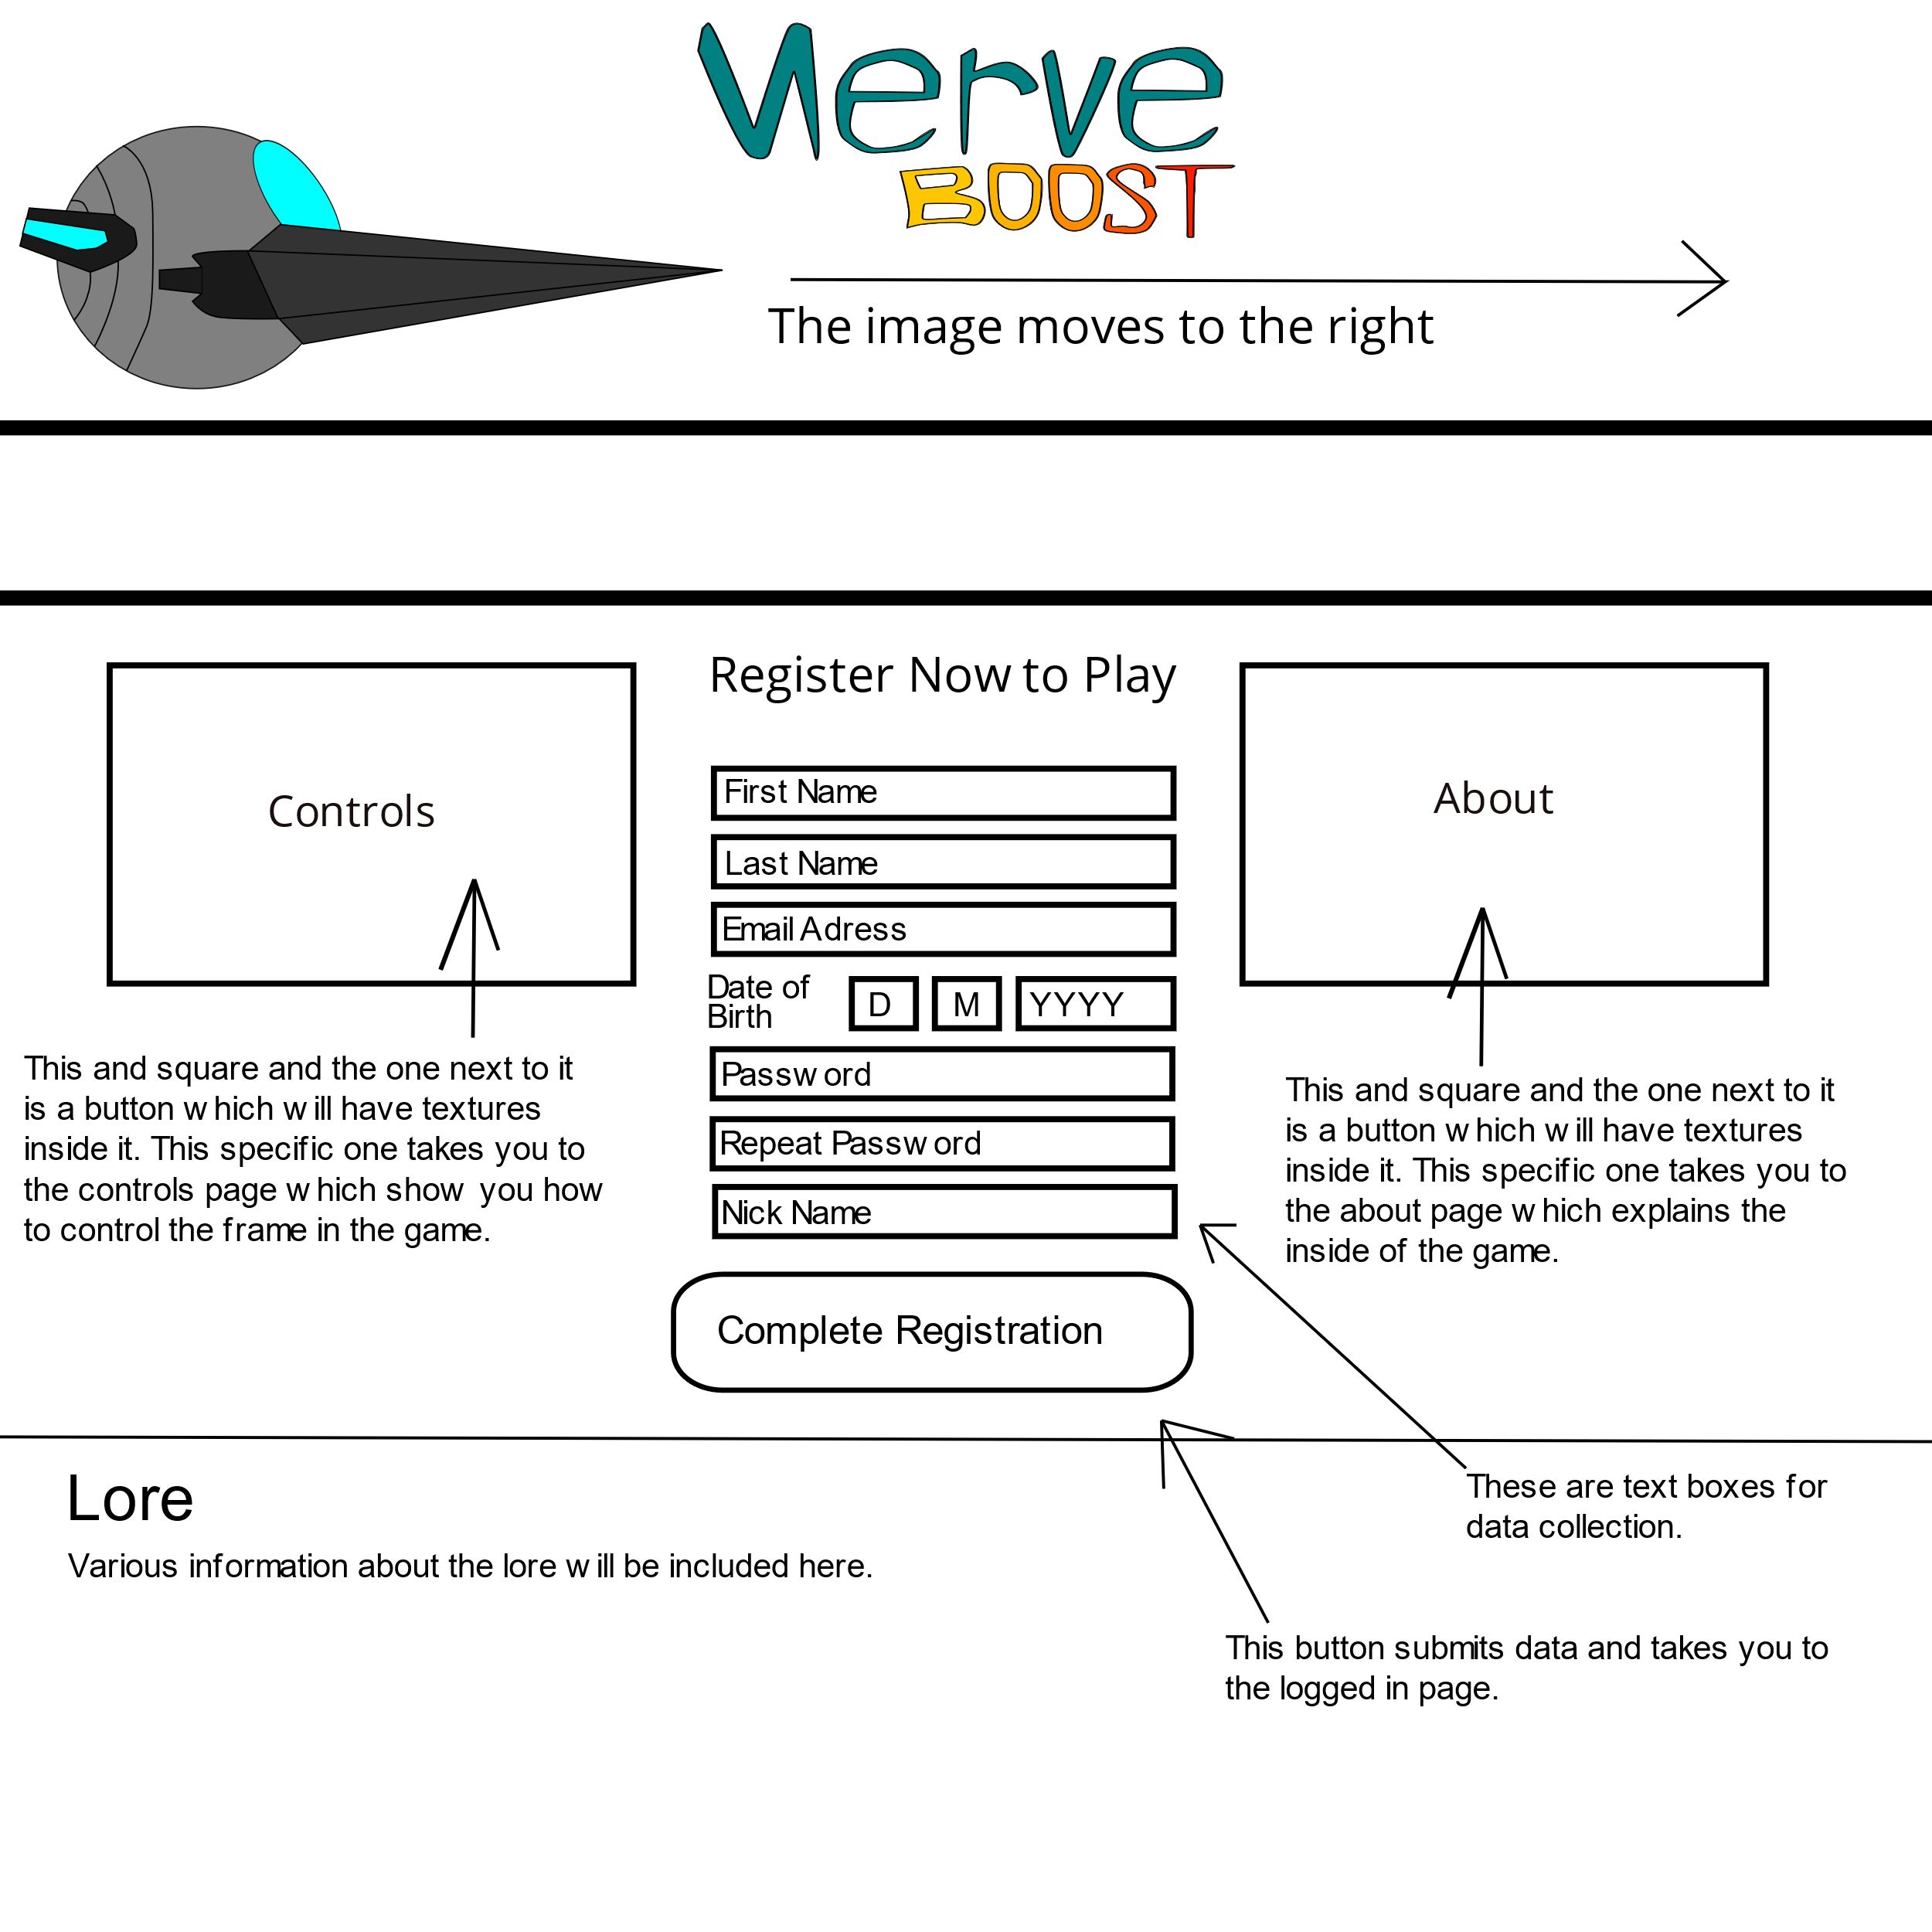

**Logged in page** is what you would see after you register or log in into the website and it allows you full access to the website.

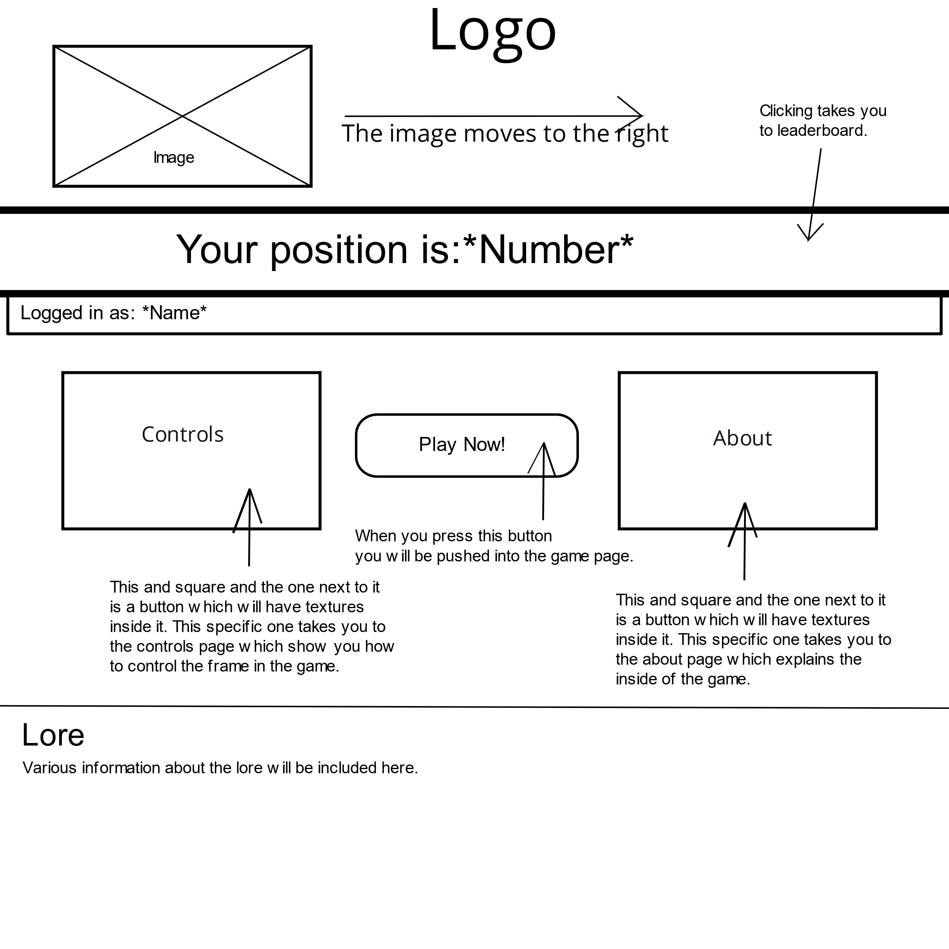

**Leader board page** is what you would see if you clicked on the giant scoreboard that shows your place when you are logged in.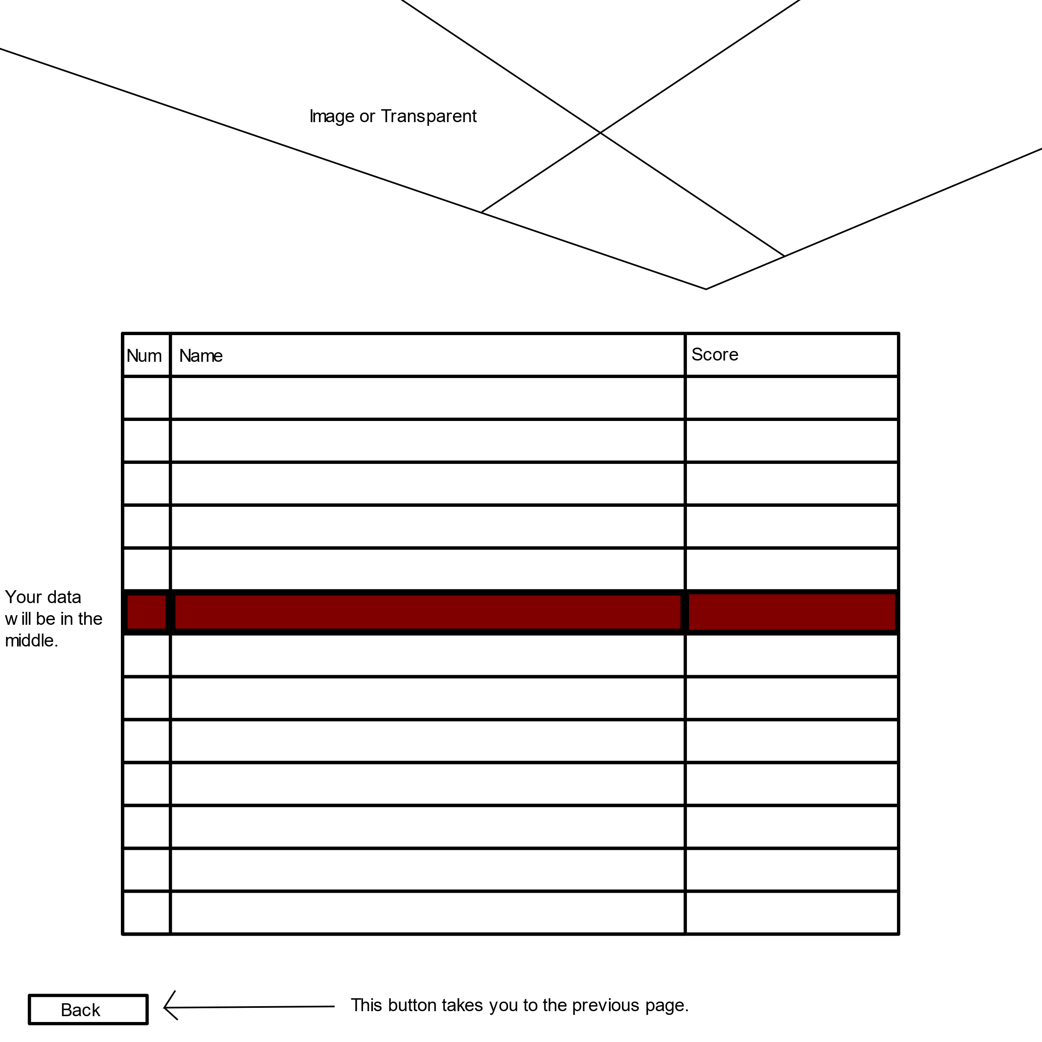

**About us page** is what you would see if you would have clicked the giant square about us button.

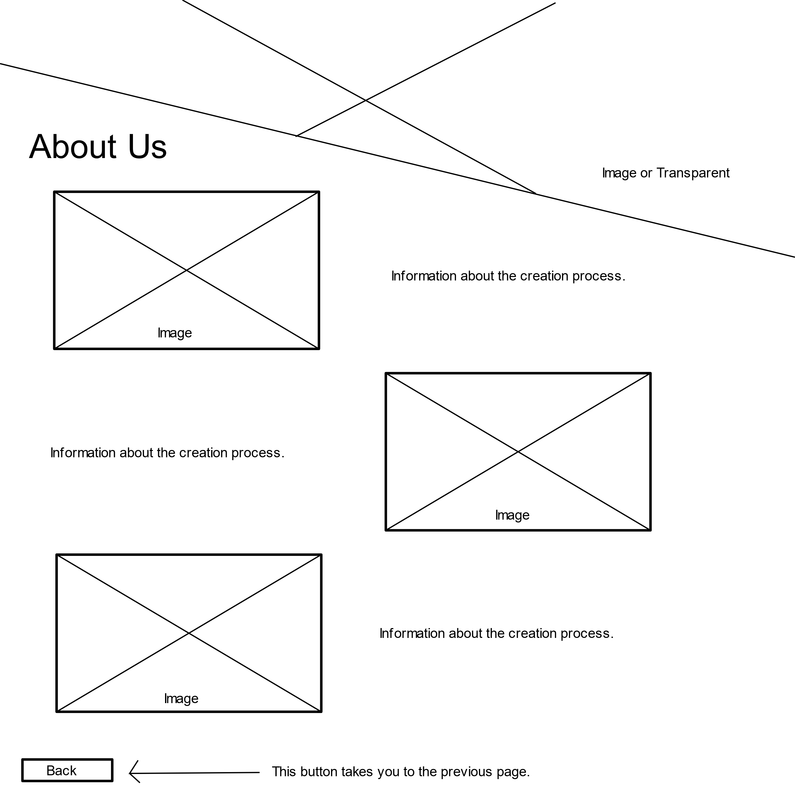

**Controls page** is what you would see if you clicked the giant square controls button. This page would show you the controls and explanations with arrows.

# 

# **Game**

**Description**

The game is a pretty straightforward galaga type of thing where you use your mouse to avoid obstacles and/or possibly try to shoot them. My game will hopefully have a powerup system which will make the game more interesting and engaging. Main twist or as one would call the main catch is that you need to match your system synchronization by matching it’s patterns otherwise you will be debuffed and the game will be harder. So you would tap spacebar in accordance with what the system tells you and if you fail your ship will no work well. The obstacles will be randomly generated and you will be expected to dodge or destroy. The longer you survive the better you score. I am also thinking of turning the leader board points into actual points you could spend and powerup and use them for purchase of possibly different colours and frames.

Key features of my game will be:

* Synchronization matching via spacebar tapping.
* Leader board points might be usable.
* Random obstacles to dodge.
* Powerups.
* Cool music.
* Possibly enemies which will shoot in a pattern or simpy at you.

**Example Wireframes**